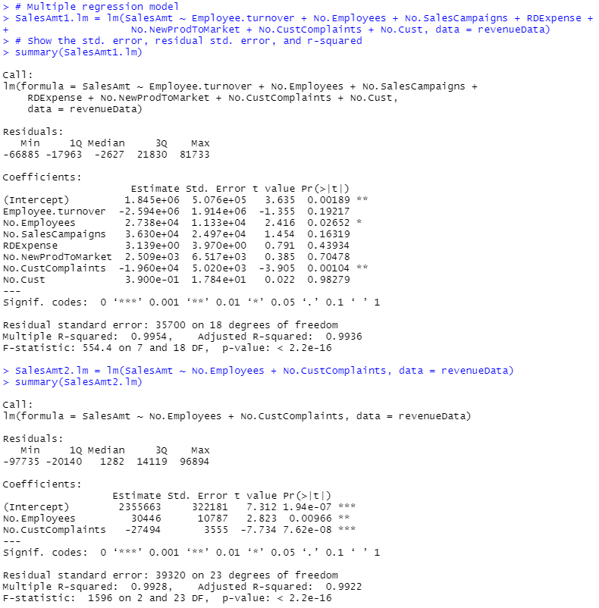

From the first multiple regression model, we can see that the P-value of all but two variables were over the p>0.05 threshold, therefore determined to not be significant enough for the final model of the multiple regression model. The remaining variables, No.Employees and No.CustComplaints were both highly correlated to the SalesAmt variable. When running the second multiple regression model with just the significant variables, we can see that the No.Employees has an estimate of 30446 and the No.CustComplaints has -27494. This means for every additional employee, SalesAmt can be expected to increase by $30446, and for each customer complaint SalesAmt can be expected to decrease by $27494. However, No.Employees is not as significant as No.CustComplaints as No.Employees could be explained by a more popular store or larger store that makes more money will often have more employees. In a business perspective, the most important variable to focus on for increasing SalesAmt is to lower the number of customer complaints through providing the best possible service experience and addressing existing complaints.